DOKUMENTASI PREDIKSI KREDIT MACET DENGAN ENSEMBLE LEARNING

1. Diagram Alur Analisis Model
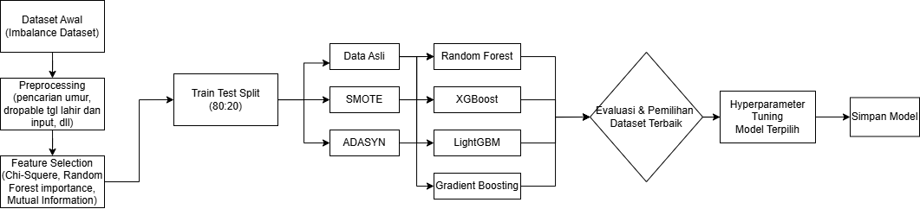
2. Preprocessing & Penanganan Imbalance
2.1. LOADING DATA
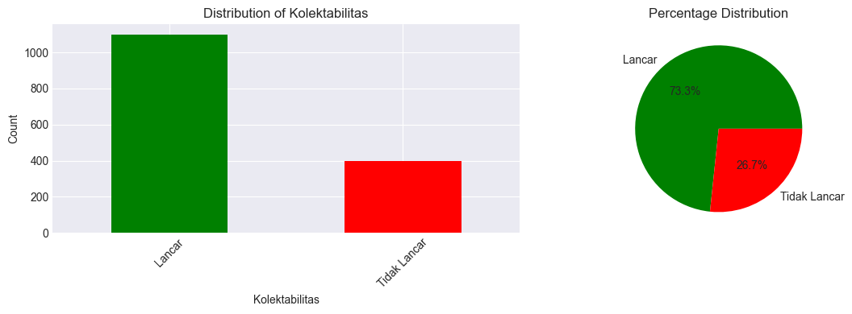
- Dataset Original: 1500 baris × 24 kolom
- Target Variable: KOLEKTABILITAS (2 kategori)
  - Kelas 1: Lancar (1100 data)
  - Kelas 2: Tidak Lancar (400 data)
2.2
1.2. FEATURE SELECTION & REMOVAL
Kolom yang DIHAPUS (2 kolom):
- Hasil Prescreening SLIK (leakage_features)
- Hasil Prescreening (leakage_features)
Kolom yang DIPERTAHANKAN (13 kolom):
- FITUR NUMERICAL (3 kolom):
- Pekerjaan
- Usia
- Status Pernikahan
- Produk
- Sub Produk
- Plafond
- Jangka Waktu
- Hasil Prescreening SIPKUR
- Hasil Prescreening Dukcapil
- Hasil Prescreening DHNBI
- Status Aplikasi
- TARGET VARIABLE (1 kolom):
12. KOLEKTABILITAS : Target prediksi (2 kelas)
- HASIL FEATURE SELECTION
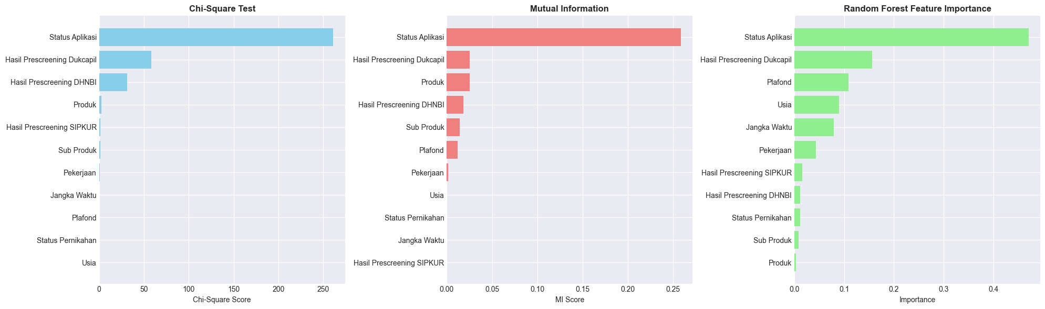
- HASIL OVERSAMPLING
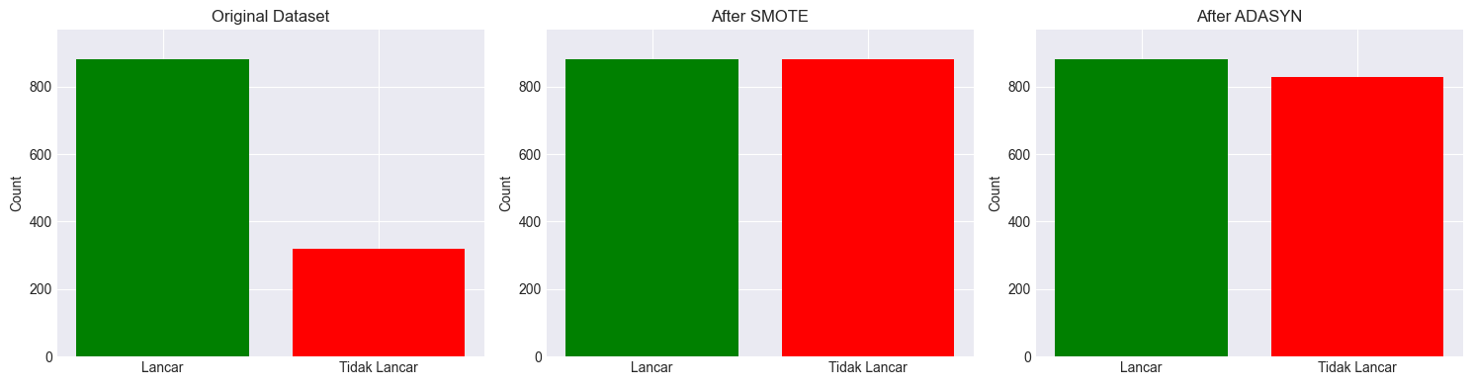
1. ORIGINAL DATASET:
Training set distribution:
Lancar: 880 (73.33%)
Tidak Lancar: 320 (26.67%)
2. APPLYING SMOTE...
After SMOTE:
Lancar: 880 (50.00%)
Tidak Lancar: 880 (50.00%)
3. APPLYING ADASYN...
After ADASYN:
Lancar: 880 (51.49%)
Tidak Lancar: 829 (48.51%)
4. SUMMARY:
Original : 1200 samples
SMOTE : 1760 samples (+560)
ADASYN : 1709 samples (+509)
Test set : 300 samples (same for all)
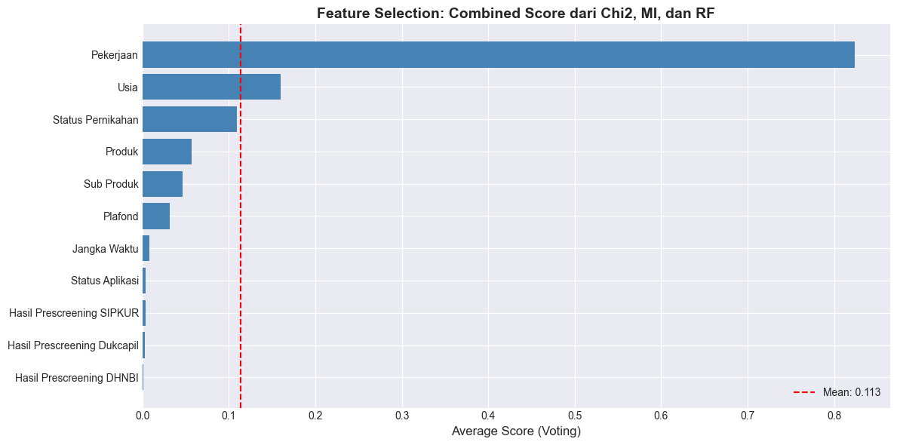
SELECTED FEATURES: 10 dari 11
Features selected by RFE: 7
Features selected by Score: 7
Final union: 10

Final Selected Features (sorted by combined score):
1. Pekerjaan (Score: 0.8236) ✓ RFE ✓ Score
2. Usia (Score: 0.1596) ✓ RFE ✓ Score
3. Status Pernikahan (Score: 0.1090) ✓ Score
4. Produk (Score: 0.0567) ✓ Score
5. Sub Produk (Score: 0.0464) ✓ Score
6. Plafond (Score: 0.0313) ✓ RFE ✓ Score
7. Jangka Waktu (Score: 0.0077) ✓ RFE ✓ Score
8. Status Aplikasi (Score: 0.0040) ✓ RFE
9. Hasil Prescreening SIPKUR (Score: 0.0037) ✓ RFE
10. Hasil Prescreening Dukcapil (Score: 0.0029) ✓ RFE

Feature Importance
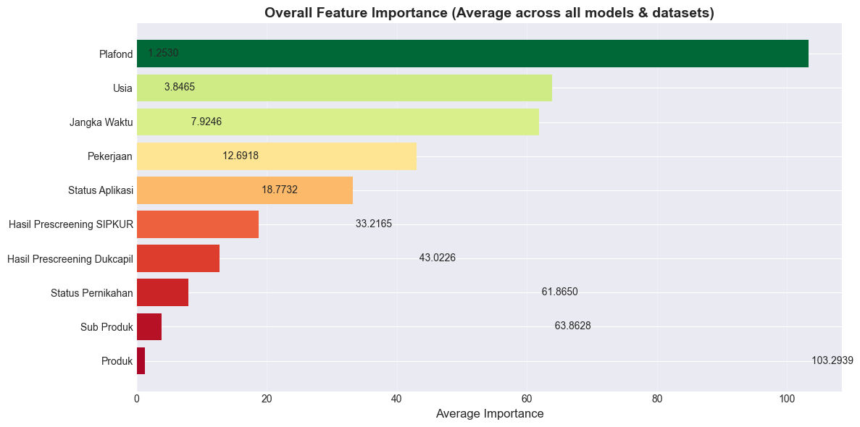
3. HASIL EVALUASI MODEL PER DATASET
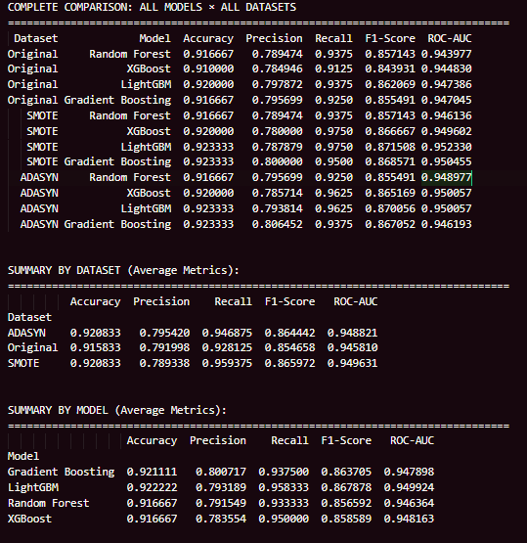

Evaluasi dengan mempertahankan kolom Hasil Prescreening SLIK, Hasil Prescreening (aneh bingits bu)
